# 

# 

# 

# How to Become a CoPI: A Guide

CIS Senior Project

Joseph Gonzalez

Florida International University

VIP 4.0



***Preface***

In VIP, PI/CoPI are super users, in charge of approving projects, and verifying accounts, and able to access every feature of the site. In order to facilitate developing for the site, it is essential to become a PI/CoPI on the localhost server. This guide will briefly explain the process of manually adjusting your account user type to PI/CoPI via the MongoDB.

***Prerequisites***

For this guide, it is assumed you have completed the following:

* Download and Install MongoDB
* Download and Install Node.js
* Downloaded the current version of VIP onto your system.

***Step 1: Setup***

Before we begin, let’s make sure your files are where they need to be. You will need to open your C drive (or whichever drive you installed MongoDB) and navigate to the “data” directory.

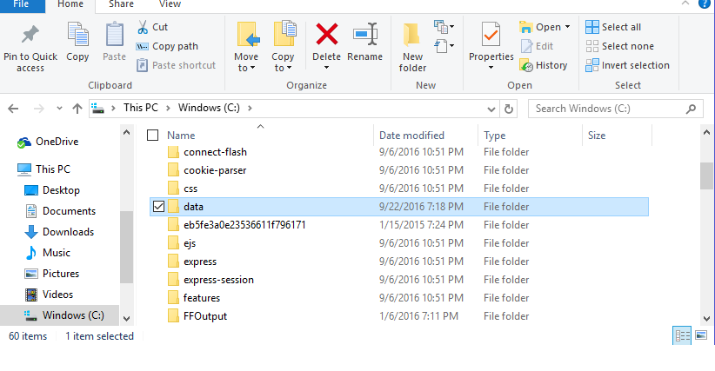

This is going to be the directory where your MongoDB collections are stored. Among the VIP files, should be a data file. You need to take those files, and place them in this data file. The results will look something like this

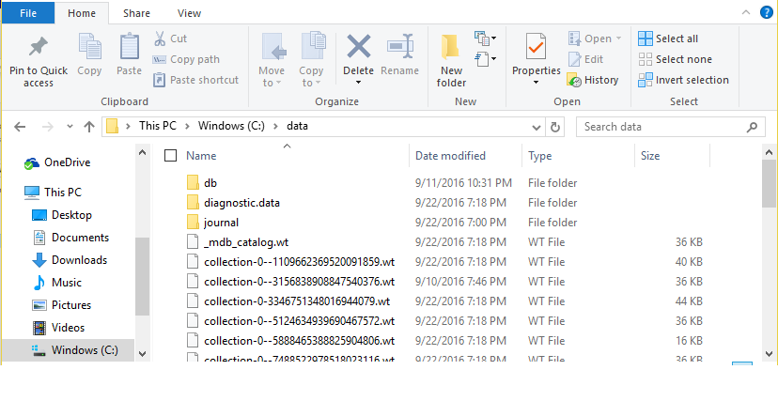

Once this is setup, you’re ready to begin.

***Step 2: Running VIP***

So, we begin by opening 3 command prompts. In 2 of these command prompts, you will need to navigate to the “bin” folder in MongoDB, and in the last, you will need to navigate to the “Code” folder in the VIP directory.

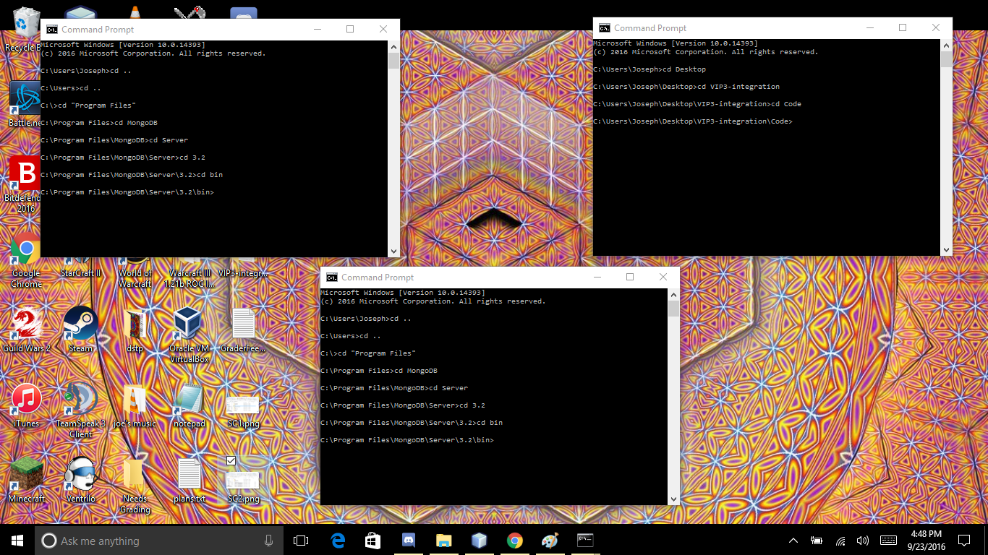

First, in one of the Mongo Command Prompts, we need to run mongod.exe, but we need to set it down the database we set up in step one. To do this enter the following into command prompt

Mongod.exe --dbpath /data/

(enter this verbatim)

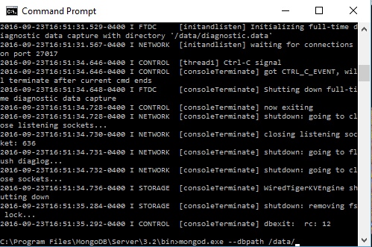

Press enter, and in the other MongoDB command prompt, run mongo.exe

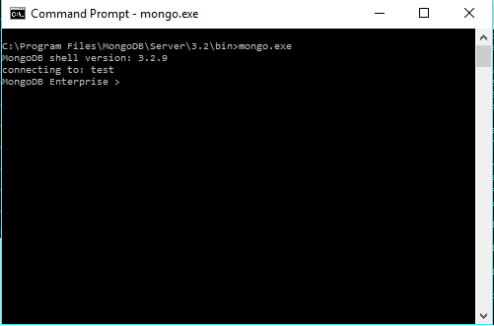

Finally, in the last command line, we now run the server, by entering the following:

node server.js

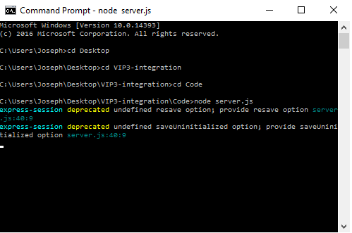

From here, go to your preferred web browser, and in the URL bar enter localhost:3000 to access your locally hosted VIP server.



At the moment, your account is not in our database. To add it, need to login to VIP on your localhost for the first time. You can do so by clicking the “Login” button on the top right hand of the screen as seen above. From there, simply click the login via google button on the next page.

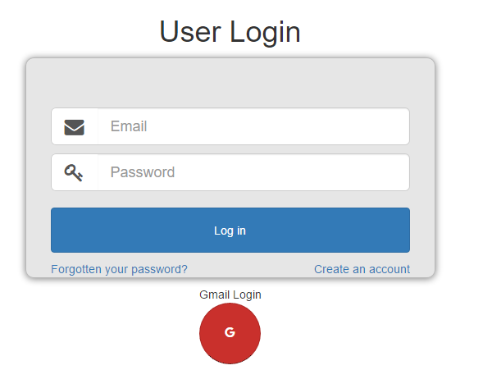

(Note: Once you login you will be redirected to the live server (vip.fiu.edu) simply go back to localhost:3000)

Now that you’ve logged in, your account information has been added to the users collection in the database, which means we can modify it in the database.

***Step 3: Modifying the Database***

Now that your user information is in the database, we can modify your account status manually. First, we need to switch to the right database. Open up the command prompt where you are running mongo.exe, and enter “show dbs” minus the quotes. This will give a list of the databases on the system. Among them you should see “admin”. This is the database we’ll be using. To access it, simply enter “use admin” minus the quotes.

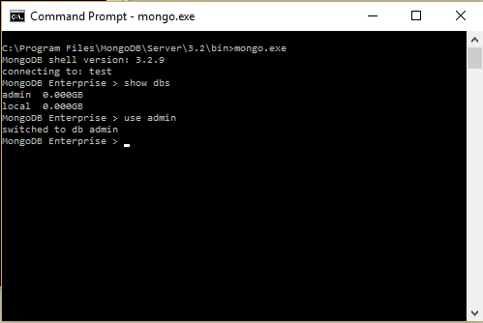

From here, if you enter “show collections” you will see a list of the collections in the database. Among them is the “users” collection which contains your user information. To view the tuples in the collection enter “db.users.find()” without the quotes.

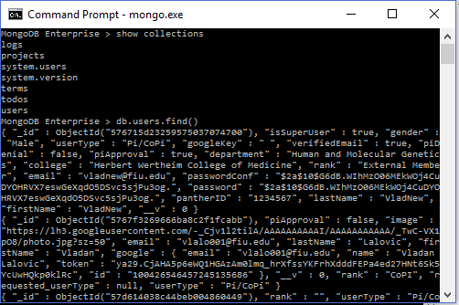

This command lists all of the user accounts on the site. Among them now should be yours, quickly look through the collection to confirm.

From here, we now use the update() function to modify your userType from Student to PI/CoPI. The update() command takes 2 arguments, an identifier so that mongo knows which tuple to alter, and a target tuple that you’re going to alter. For this example we’re going to use your last name as the identifier, and user type as the target. So to alter your account enter following line into the command prompt:

db.users.update({ “lastName” : “ <your last name> “ } , {$set”:{ “userType” : “Pi/CoPi”}})

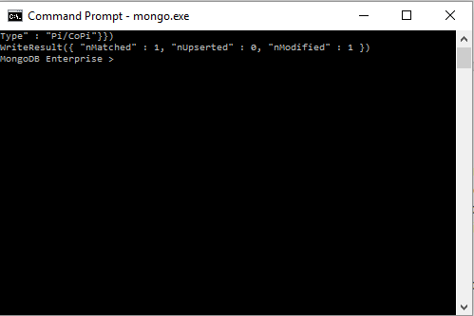

The write result line indicated how many tuples were matched, and how many were modified, as seen above it should be 1 and 1. Re-enter the db.users.find() command to verify your updated user Type, or simply return to the localhost VIP and observe your new Pi/CoPi status to confirm.

***Conclusion***

Now you are officially a PI/CoPI on the VIP local host, and are able to access all the features of the site at your leisure, making it navigating the entire site a breeze. When on the site you should see some updated features, such as the tool icon, and notifications.



Now you are ready to begin working on the VIP site!